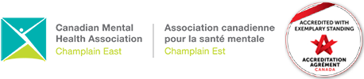

Welcome to CMHA Champlain East

As part of service delivery at CMHA, you will be creating your mental health Recovery plan through a standardized assessment tool called the Ontario Common Assessment of Need (OCAN). This tool is used by community mental health services to identify your needs.

Steps to the OCAN:

Getting to Know You
This is an opportunity to identify your needs using the Ontario Common Assessment of Need (OCAN) Self-Assessment

Planning Together
Let’s create a Recovery plan together during our visits

This plan is led by you and informs the work that we will do together

Reviewing Progress
Let’s review your progress in your Recovery

We will review your assessment together at least every six months or as often as you would like

You can start thinking about your Recovery goals today. What does Recovery look like for you?

1.

2.

3.

4.

5.

If you are experiencing a crisis, please call the Mental Health Helpline at 1-866-531-2600, or go to your local Emergency Department

